Foundations of Data Science (CS F320)

Assignment 3

**Loss for Part A:** 21.851

The coefficients take the following values: [455.34,-1.99,-0.227,0.061,-0.161]

The values have been subtracted by column wise means before applying gradient descent

**Loss for Part B:** 22.6

The values have been subtracted by column wise means and divided by column wise standard deviations for Part C

**Part C:**

**L1 Regularisation:**

Regularisation Coefficient: 0.0001

Loss: 22.059

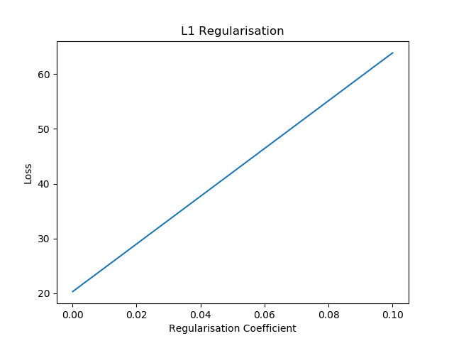

The coefficients turn out to be [454.44978475697184, -13.81951625044771, -3.659378438341597, 0.5605411702110629, -2.0168394355828623]

**L2 Regularisation:**

Loss: 22.297

Regularisation Coefficient: 0.001

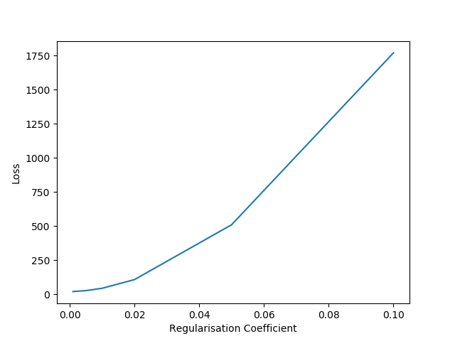

The coefficient values become :

[453.99583885087213, -13.763276532722697, -3.69029765161939, 0.5734726475960247, -1.9958098130615516]

Based on the graphs, as the value of regularisation coefficient increases, the corresponding validation errors also increase.

Regularization controls the values of the coefficients and allows complex models to be trained on data sets of limited size without severe over-fitting, essentially by limiting the effective model complexity.